Making Measurements Activity (100 points)

USE THE METRIC RULER TO MAKE THE FOLLOWING MEASUREMENTS (1 point each):

Length of the line in mm _____________ Length of the line in cm ______________

**Rectangle Length**

**Rectangle Width**

Length of the rectangle in mm _____________ Length of the rectangle in cm _______________

Width of the rectangle in mm ______________ Width of the rectangle in cm _______________

**HINT! These are the parts of a circle:**

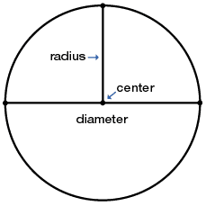

Radius of the circle in mm ____________ Radius of the circle in cm ______________

Diameter of the circle in mm _____________ Diameter of the circle in cm ______________

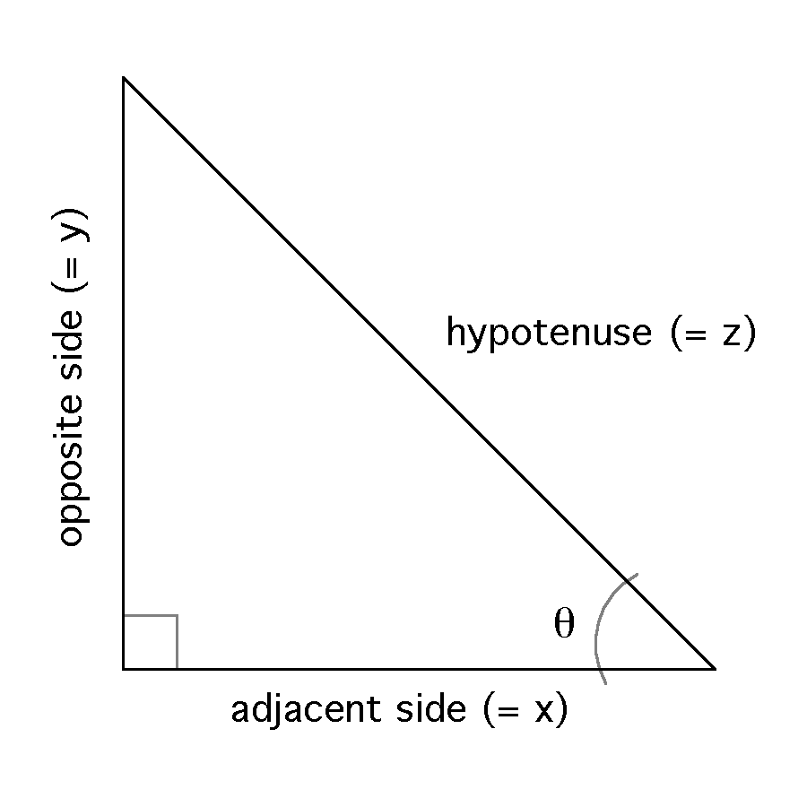

**HINT! These are the sides of a right triangle:**

Length of the hypotenuse in mm ____________ Length of the hypotenuse in cm _____________

Length of the opposite in mm ____________ Length of the opposite in cm _____________

Length of the adjacent in mm ____________ Length of the adjacent in cm _____________

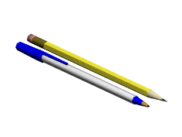USE THE METRIC RULER TO MAKE THE FOLLOWING MEASUREMENTS IN YOUR CLASSROOM (1 point each):

Length of your pen/pencil in mm _____________ Length of your pen/pencil in cm _____________

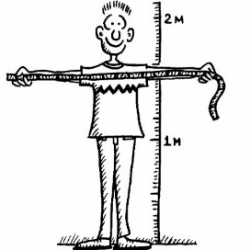

Your height in mm ______________ Your height in cm _______________

Width of your desk in mm _______________ Width of your desk in cm ________________

Length of your desk in mm _______________ Length of your desk in cm ________________

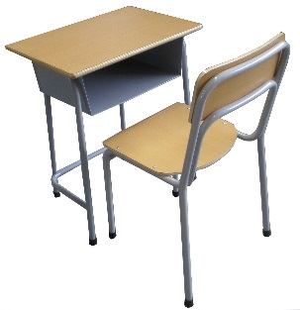Height of your desk in mm _______________ Height of your desk in cm ________________

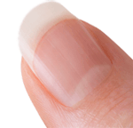Height of chair in mm _____________ Height of chair in cm ____________

Length of your fingernail in mm _____________ Length of your fingernail in cm ______________

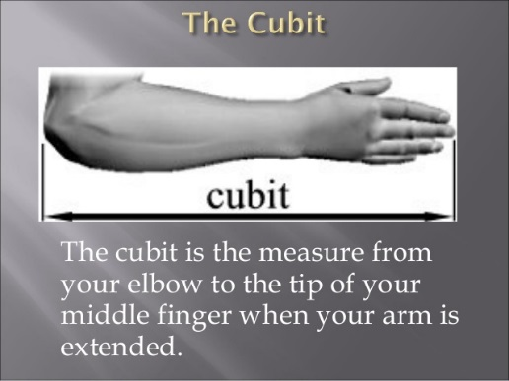Length of the tip of your middle finger to your elbow in mm _______________

Length of the tip of your middle finger to your elbow in cm _______________

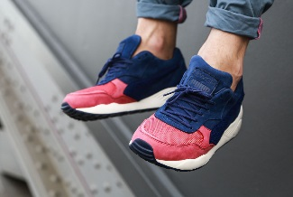Length of your shoe from heel to toe in mm _______________

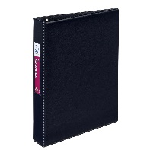Length of your shoe from heel to toe in cm _______________

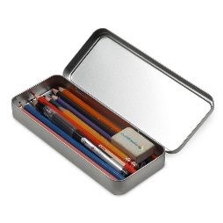Length of your binder in mm ___________ Length of your binder in cm ______________

Width of your binder in mm ___________ Width of your binder in cm ______________

Length of your pencil case in mm ____________ Length of your pencil case in cm ____________

Width of your pencil case in mm ____________ Width of your pencil case in cm _____________

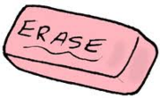Length of your eraser in mm _____________ Length of your eraser in cm ______________

Width of your eraser in mm ____________ Width of your eraser in cm _____________

Height of your eraser in mm _____________ Height of your eraser in cm ________________

CIRCLE THE *BEST* METRIC UNIT FOR EACH MEASUREMENT (1 point each)

Length of an eye lash mm cm m km

Height of a flagpole mm cm m km

Length of a spaghetti noodle mm cm m km

Distance from Flagstaff to Phoenix mm cm m km

Height of a house mm cm m km

Diameter of a bracelet mm cm m km

Length of the tail of a chihuahua mm cm m km

Whiskers of a hamster mm cm m km

Height of your Mom mm cm m km

Distance from school to your house mm cm m km

Height of a Tyrannosaurus Rex mm cm m km

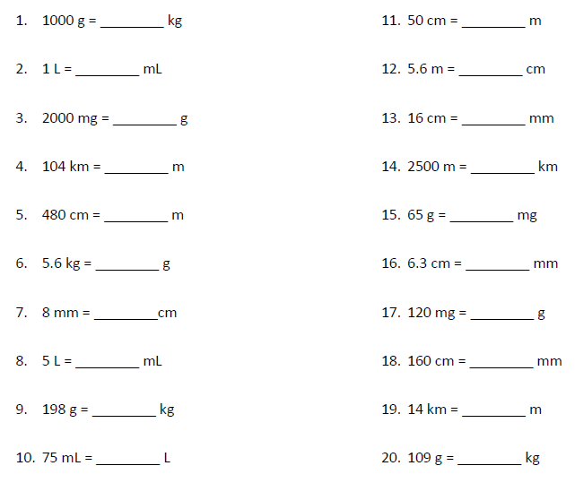METRIC PRACTICE PROBLEMS (1 point each):

COMPARE THE FOLLOWING USING <, >, OR = (1 point each):

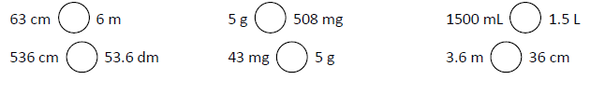

MORE METRIC PRACTICE (1 point each)

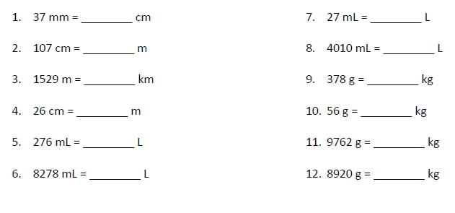

13. In your own words explain how the stair step method works below. Use complete sentences. (3 points)