PRACTICE DATA SETS! (40 points for completion)

REVIEW, STEP FOR GRAPHING:

- Determine the type of data you have: group data, data collected over time, or percentage data.
- Decide which type of graph you will use: a bar graph, a line graph, or a pie graph.
- Choose the appropriate scale for the data if you are going to make a bar graph or a line graph.
- Include all the required components of your graph type.
  - See notes page 2 - 4 in your note packet for required components

Graph the data sets on the following pages by following along with Mrs. G!

WATER BOTTLES LOST PER SCHOOL YEAR:

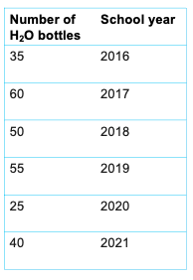

DISEASES KIDS PRETEND TO HABE TO GET OUT OF ATTENDING SCHOOL:

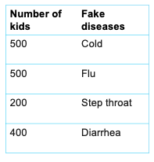

NUMBER OF TIMES MRS. G TALKS ABOUT JEYRGE PICKLESTON PER HOUR DURING SCHOOL:

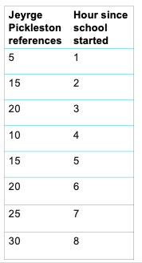

REASONS I LOST MY HOMEWORK AT BASIS CHANDLER:



