**LAB EQUIPMENT AND MEASUREMENT STUDY GUIDE**

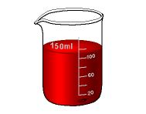Match the definition to the appropriate piece of lab equipment:

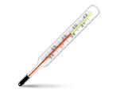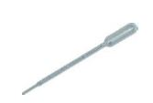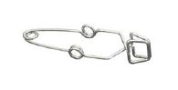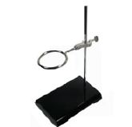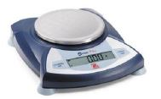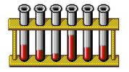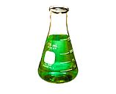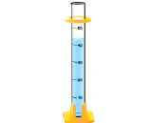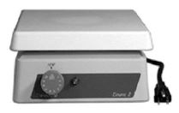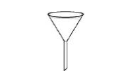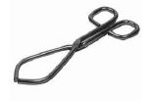

G

N

M

L

K

J

F

E

D

C

B

A

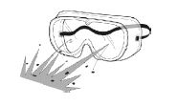

I

H

1. ________ Used to measure the temperature of a substance

2. ________ Protects scientist’s eyes from chemicals and flying objects

3. ________ Used to hold test tubes containing corrosive or hot chemicals

4. ________ Used to measure out small, specific amounts of liquid. For example, 11mL, 46mL, 52mL

5. ________ Used for measuring out VERY small amounts of liquids. For example, 0.5mL, 1mL, 3.5mL

6. ________ Used for measuring large amounts of liquid that can be mixed by swirling without spillage

7. ________ Pouring liquids into containers with small openings without spilling

8. ________Used to measure out large volumes of liquids. For example, 20mL, 40mL, 60mL, 80mL, 100mL.

9. ________ Used to hold, mix, or heat small quantities of solid or liquid chemicals

10. ________ Used to suspend beakers, flasks, or test tubes

11. ________ Used for grasping or lifting lab materials. Specifically used for lifting beakers containing corrosive or hot materials

12. ________ Used to hold several test tubes in one place

13. ________ Used to weigh out very specific amounts of a substance in grams

14. ________ Used to heat substances without using an open flame

IDENTIFY WHICH TYPE OF LAB EQUIPMENT YOU WOULD USE TO MAKE THE MEASUREMENTS DESCRIBED IN THE QUESTIONS BELOW:

1. What kind of lab equipment would you use to measure out 1.5 mL of a liquid?

2. What kind of lab equipment is used to measure the mass of an object in grams?

3. What kind of lab equipment is used to heat substances without using an open flame?

4. What kind of lab equipment is used to measure our 57 mL of a liquid?

5. What kind of lab equipment is used to measure out 100 mL of a substance?

6. What kind of lab equipment is used to measure out 100 mL of a liquid that you need to swirl?

7. What kind of lab equipment is used to hold test tubes and beakers that have corrosive or harmful substances in them?

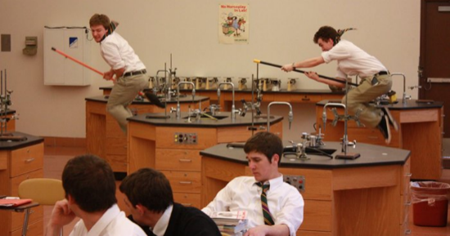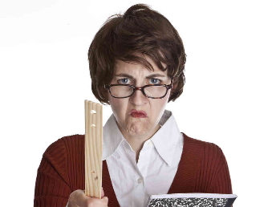LIST THE THREE LAB SAFETY RULES:

1.

2.

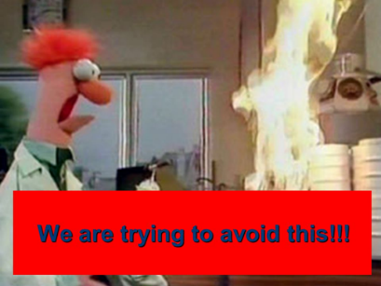

3.

COMPLETE THE FOLLOWING QUESTIONS ABOUT THE STAIR STEP METHOD FOR METRIC CONVERSIONS:

Fill in the boxes for the stair-step diagram.

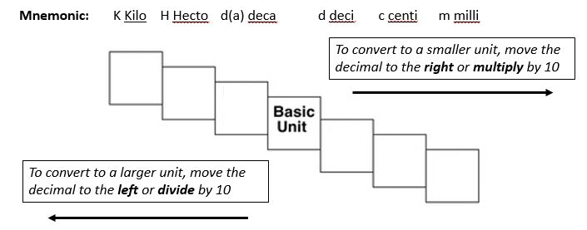**Mnemonic:** K________ H_______ d(a)_______ d________ c_________ m_________

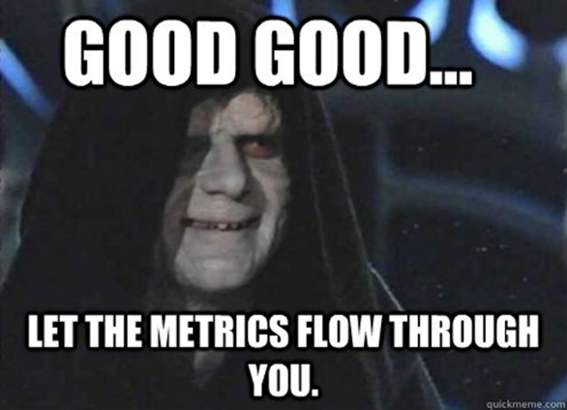DRAW A LINE FROM THE CORRECT METRIC MEASURE TO THE CORRECT BASE UNIT:

Meters (m)

Mass

Grams (g)

Liters (l)

Volume

Length

IDENTIFY WHAT METRIC MEASURE EACH ABBREVIATION REPRESENTS:

1. km = _____________ 2. daL = ____________ 3. dg = ____________

4. cL = ____________ 5. hg = ____________ 6. m = ____________

7. mg = ____________ 8. daL = ____________ 9. cg = ____________

INDENTIFY WHAT ABBREVIATION IS USED FOR EACH METRIC MEASURE:

1. Dekagram = _____ 2. Centiliter = _____ 3. Millimeter = _____

4. Hectometer = _____ 5. Decimeter = _____ 6. Kilogram = _____

7. Hectoliter = _____ 8. Liter = _____ 9. Dekaliter = _____

WHAT TYPE OF MEASUREMENT IS INDICATED BY THE FOLLOWING UNITS: MASS, VOLUME, OR LENGTH?

1. g = ____________ 2. mg = ____________ 3. L = ____________

4. mm = ____________ 5. cL = ____________ 6. kg = ____________

7. hg = ____________ 8. m = ____________ 9. dL = ____________

COMPLETE THE FOLLOWING METRIC CONVERSION PROBLEMS USING MULTIPLICATION OR THE STAIR-STEP METHOD:

1) 1000 mg = **_______ g** 2) 198 g = **________ kg** 3) 8 mm = **________cm**

4) 160 cm = **_______ mm** 5) 75 mL = **_________ L** 6) 6.3 cm = **______ mm**

7) 109 g = **________ kg** 8) 50 cm = **_________m** 9) 5.6 m =________ **cm**

10) 250 m = **_________ km** 11) 5 L = **_________ mL** 12) 26,000 cm = **____ m**

13) 14 km = **________m** 14) 16 cm =______ **mm** 15) 56,500 mm = __**km**

16) 1 L = **_________ mL** 17) 65 g = **________ mg** 18) 27.5 mg = **______ g**

19) 480 cm = **______ m** 20) 2500 m = **_____ km** 21) 923 cm = **______ m**

22) 27 g = **________ kg** 23) 355 mL = **_________ L** 24) 0.025 km = ____**cm**

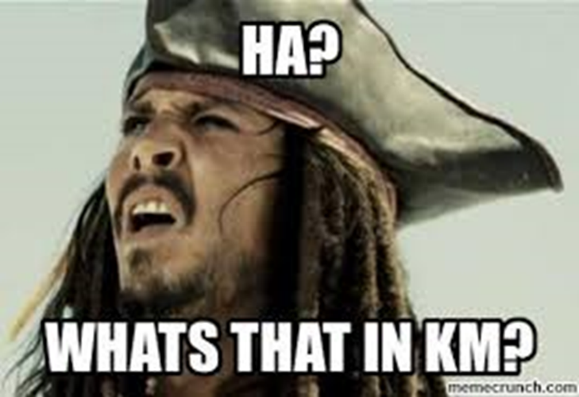

CIRCLE THE LARGER VALUE:

**HINT! Convert one of the values to the same units as the other value *before* comparing!!!**

1) 12g or 340kg 2) 22.65 L or 22,650 dL 3) 12 mm or 12 cm

4) 4,500 mL or 4.5 hL 5) 314 hg or 26 kg 6) 17 dm or 1.7 dam

7) 200 kg or 200 dag 8) 730 cg or 7.3 dg 9) 2,240 mL or 38 L

10) 5.56 hm or 432 m 11) 48 L or 4.8 hL 12) 7,666 dg or 432 g

13) 1.45 daL or 14 L 14) 66.5 cm or 66.5 km 15) 84 dag or 623 cg

16) 4.34 g or 4.34 cg 17) 26 m or 345 cm 18) 74 hg or 92 dag

19) 5.6 kL or 5,600 hL 20) 44 mm or 44 m 21) 2,310 dag or 423 kg

22) 5,000 L or 5,500 dL 23) 62.3 cm or 560 mm 24) 4.57 hg or 700 g



COMPLETE THE FOLLOWING CONCEPTUAL METRIC CONVERSION PROBLEMS:

1. Sam weighed and measured an infant at the clinic today. The baby weighed 8.5 kg and was 60.5 cm long. The baby’s mother wanted to know the baby’s ***weight in g and length in m***. Show all your work.

2. Sam counted 12 liters of hand sanitizer in the storage cabinet. He fills the dispensers in seven of the examination rooms as follows: 350 mL, 600 mL, 475 mL, 580 mL, 650 mL, 720 mL and 500 mL. Answer the following questions and show all your work.

a. How many total ***milliliters*** did Sam use to fill the dispensers?

b. After filling the dispensers, how many ***liters*** of sanitizer remain in the storage cabinet?

3. Sam helped you prepare 35 sets of injections of dopamine for the clinic this week. Each injection is 50 milliliters. How many ***liters*** of dopamine did the clinic use this week?

4. The clinic used 9 liters and 500 milliliters of saline solution during the last 5 weeks. On ***average***, how many ***milliliters*** of saline solution does the clinic use ***each week***?

5. Sam restocked 275 mL of children’s ibuprofen in six of the exam rooms. What is the ***total*** amount of children’s ibuprofen he used in ***liters***?

6. The clinic has 4 L of polio vaccine on hand. ***How many 10 mL*** polio injections can be prepared from this supply? Show all your work.

ANSWER THE FOLLOWING QUESTIONS ABOUT MEASURING VOLUME:

1. Explain how you would determine the volume of an irregular shaped object using water displacement.

2. What is the volume of the liquid in the graduated cylinders pictured below? Pay attention the ***scale*** of milliliters on the graduated cylinders!

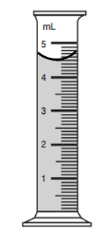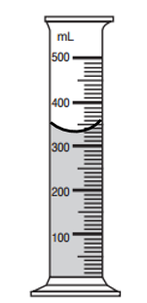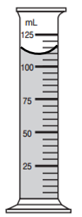

Volume:

Volume:

Volume:

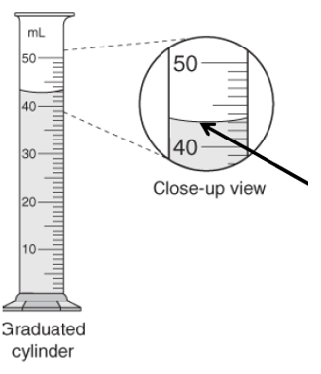3. What is the area where the arrow is pointing to called and how is it formed?

4. To measure the volume of a marble you fill a graduated cylinder with 100 mL of water and add the marble. The water level rises to 112 mL. What is the volume of the marble? Show your work.

5. To measure the volume of a crystal you fill a graduated cylinder with 200 mL of water and add the crystal. The water level rises to 364 mL. What is the volume of the crystal? Show your work.

