**Lab Equipment and Measurement**

EQUIPMENT IDENTIFICATION AND USE

|  |  |  |
| --- | --- | --- |
| **Equipment** | **Name** | **Purpose** |
|  |  |  |
|  |  |  |
|  |  |  |
|  |  |  |
|  |  |  |
|  |  |  |

|  |  |  |
| --- | --- | --- |
| **Equipment** | **Name** | **Purpose** |
|  |  |  |
|  |  |  |
|  |  |  |
|  |  |  |
|  |  |  |
|  |  |  |
|  |  |  |

EQUIPMENT QUESTIONS

1. What does a balance measure?

2. List three (3) pieces of lab equipment designed to measure volume.

a.

b.

c.

3. What does a thermometer measure?

4. Which piece of laboratory equipment should you use for the following tasks?

a. Heating water without using an open flame _______________________________.

b. Measuring exactly 43 mL of water __________________________________.

c. Weighing out 120 grams of sodium chloride ________________________________.

d. Protecting your eyes from chemicals, flying objects, etc. ______________________________.

e. Holding a beaker full of hot liquid __________________________________.

f. Pouring liquid into containers with small openings __________________________________.

g. Measuring out very small amounts of liquid ______________________________.

h. Holding a test tube ________________________________________.

j. Hold several test tubes ____________________________________________.

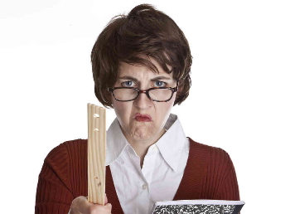LAB SAFTEY

Rule #1:

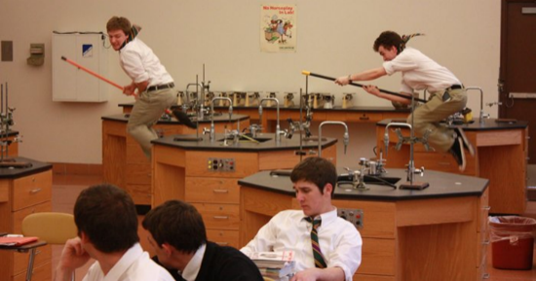

Rule #2:

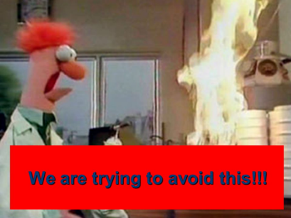Rule #3:

METRIC MEASUREMENT AND CONVERSIONS

The beauty of the metric system is that it’s based on the number _________.

Unit conversions using the stair-step method: Fill in the boxes for the stair-step diagram.

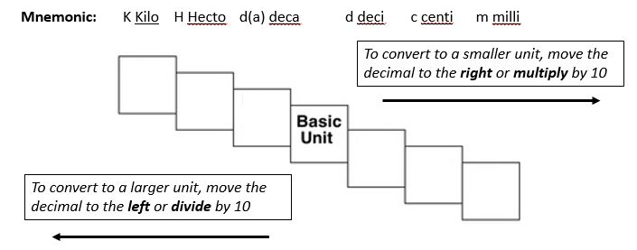**Mnemonic:** K________ H_______ d(a)_______ d________ c_________ m_________

Example:

4 km = ____________m

How many “jumps” does it take?

4._____.______.______. = 4000m

How to use the stair-step method:

1. Determine your starting point
2. Count the “jumps” to your ending point
3. Move the decimal the same number of “jumps” in the same direction

TRY THESE CONVERSIONS USING THE STAIR-STEP METHOD:

1000 mg = ___________ g 1 L = __________ mL 160 cm = ____________ mm

14 km = ___________ m 109 g = ________ kg 250 m = ____________ km

COMPARE THE FOLLOWING USING <, >, or =:

**HINT! Convert one of the values to the same units as the other value *before* comparing!!!**

56 cg ______ 6 g 36 dm _______ 3.6 cm 5 km ______ 508 m

1500 mL ______ 15 L 7 g ______ 698 mg 63 cm ______ 6 m

LENGTH

________________ is the measurement of _____________________ - how far one thing is from another.

The metric base unit for length is the ______________ (____).

WRITE THE CORRECT ABBREVIATION FOR EACH METRIC UNIT OF LENGTH:

1. Kilometer ______ 5. Dekameter ______

2. Meter ______ 6. Centimeter ______

3. Milimeter ______ 7. Hectometer ______

4. Decimeter ______

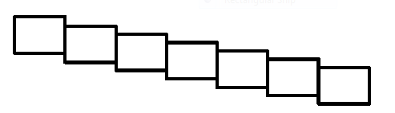FILL IN THE STAIR-STEPS FOR LENGTH:

WHAT DOES EACH UNIT REPRESENT?

1. mm = 4. km = 7. hm =

2. cm = 5. dm =

3. m = 6. dam =

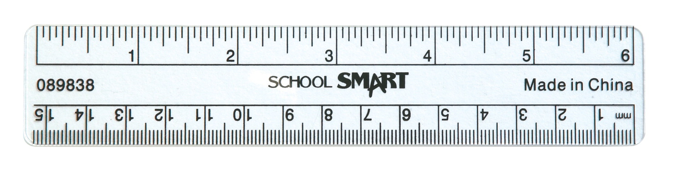

HOW MUCH DO EACH OF THESE EQUAL?

1) 1 m = _________ cm 2) 1 cm = _________ mm 3) 1 km = _________ m

WHICH MEASUREMENT IS THE LARGEST? CIRCLE YOUR ANSWER FOR EACH PAIR.

1) 14 mm or 1 cm 4) 145 m or 145 km

**HINT! Convert one of the values to the same units as the other value *before* comparing!!!**

2) 334 m or 1 km 5) 30 mm or 3.4 cm

3) 1 m or 990 cm 6) 10 km or 1000 cm

VOLUME

___________________ is the measurement of the space an object takes up.

The metric base unit for volume is ____________________ (_____).

WRITE THE CORRECT ABBREVIATION FOR EACH METRIC UNIT OF VOLUME:

1. Kiloliter ______ 5. Dekaliter ______

2. Liter ______ 6. Centiliter ______

3. Milliliter ______ 7. Hectoliter ______

4. Deciliter ______

FILL IN THE STAIR-STEPS FOR VOLUME:

WHAT DOES EACH UNIT REPRESENT?

1. mL = 4. kL = 7. hL =

2. cL = 5. dL =

3. L = 6. daL =

HOW MUCH DO EACH OF THESE EQUAL?

1) 1L = _________ cL 2) 1 cL = _________ mL 3) 1 kL = _________ L

WHICH MEASUREMENT IS THE LARGEST? CIRCLE YOUR ANSWER FOR EACH PAIR.

1) 14 mL or 16 cL 4) 148 L or 148 kL

**HINT! Convert one of the values to the same units as the other value *before* comparing!!!**

2) 26 L or 17 kL 5) 300 mL or 3.4 cL

3) 11 L or 1000 cL 6) 1000 kL or 10 cL

HOW TO READ MEASURMENTS OF VOLUME ON A GRADUATED CYLINDER:

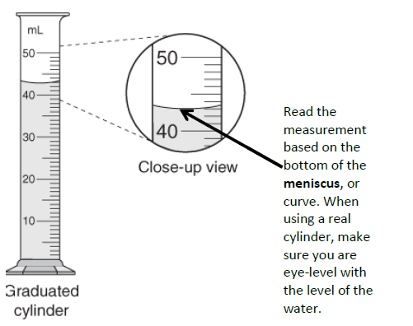

Read the measurement based on the _______________ of the ________________, or curve.

To get an ____________________ measurement, make sure you are _____________________ with the level of the water.

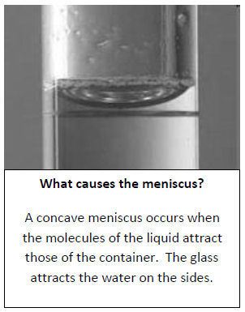

**What causes the meniscus?**

A concave meniscus occurs when the molecules of the liquid ______________the molecules of the container.

The_____________ attracts the water on the sides.

This is due to a property of water called_________________.

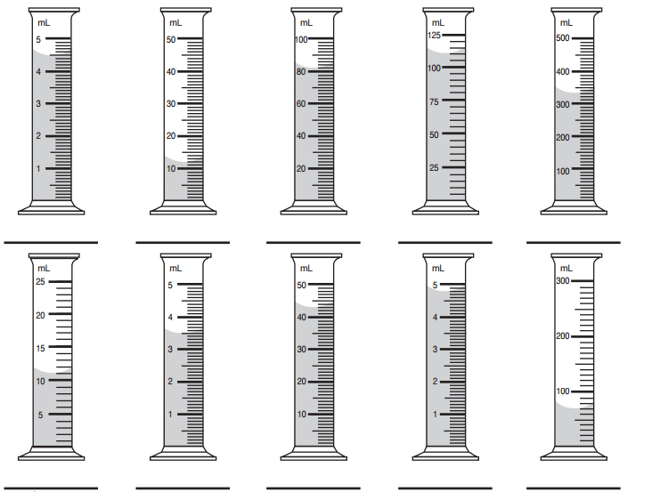READ THE MENISCUS IN THE FOLLOWING EXAMPLES AND WRITE YOUR MEASUREMENTS BELOW:

MEASURING THE VOLUME OF A SOLID IRREGULAR OBJECT:

We can measure the volume of an irregular object using ____________________________________.

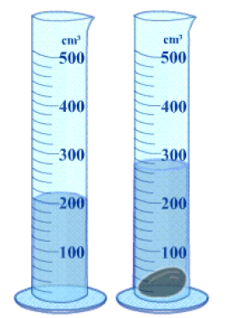

(amount of H2O with object)

(amount of H2O without object)

(difference = volume)

The measure of how much the water raises equals the

_____________________ of the

_______________________________________.

MASS

_________________is the measure of the amount of ____________________ (how much “stuff”) is in an object.

The metric base unit for mass is ___________________ (_____).

WRITE THE CORRECT ABBREVIATION FOR EACH METRIC UNIT OF MASS:

1. Kilogram ______ 5. Dekagram ______

2. Gram ______ 6. Centigram ______

3. Milligram ______ 7. Hectogram ______

4. Decigram ______

FILL IN THE STAIR-STEPS FOR MASS:

WHAT DOES EACH UNIT REPRESENT?

1. mg = 4. kg = 7. hg =

2. cg = 5. dg =

3. g = 6. dag =

HOW MUCH DO EACH OF THESE EQUAL?

1) 1 g = _________ hg 2) 1 mg = _________ cg 3) 1 g = _________ kg

WHICH MEASUREMENT IS THE LARGEST? CIRCLE YOUR ANSWER FOR EACH PAIR.

1) 12 mg or 3 cg 4) 12 g or 122 kg

**HINT! Convert one of the values to the same units as the other value *before* comparing!!!**

2) 210 g or 2 kg 5) 13 mg or 6.2 cg

3) 1 g or 998 mg 6) 15 kg or 1500 cg